Details of your portfolio
PD URL site (*Compulsory to fill up for milestone 2 and 3):
https://clarence1129.github.io/clarence.github.io/

Name of your portfolio:
Clarence Phua

Your Logo:


Describe your target audience:
My portfolio is created for young adult between 18-30 who are immersed in the world of technology, design and digital culture. My target audience should be mostly based in Singapore and southeast Asia. They should be students, start up entrepreneur who are looking for new ways to express themselves. This group of audience should vale creativity, efficiency and authenticity. They are drawn to designs that only look good but also function smoothly and serve its purpose. They keep up with social media trend and enjoy exploring fresh aesthetics and appreciate brands and creators who are relatable and inclusive. My work is crafted to connect their interest, reflect their values and make their digital experiences enjoyable and memorable.
Describe your brand story/ purpose:
I am Clarence Phua, a UI/UX web designer and creative designer based in Singapore. My journey started with a curiosity for how design could turn everyday frustration into simple, satisfying experiences. I am inspired by small moments, the way a colour palette can shift a mood, how a single interaction can make and app unforgettable, or how cultural diversity shapes the way we see design. My goal is to create a work that is effortless to use, look beautiful and resonates with people what it is made for.

Design brief
Colour scheme & Colour palette:
My primary palette is made out of mainly shades of blue and purple Blue represents trust and clarity, while purple adds a sense of creativity and sophistication. This palette creates a consistent look across the website, enhancing readability and ensuring a smooth user experience

Typography:
Agent FB, Archivo Black Regular
Theme:
Minimalistic

Layout/ Arrangement:
How will you arrange the multimodal composition in a way that makes sense for your audience and your purpose? How might you arrange ideas and elements so that your composition is effective?
Minimally 3 tabs with 2 layers of navigation
Opening page

Home
About
Contact
Portfolio

Low fidelity wireframe:
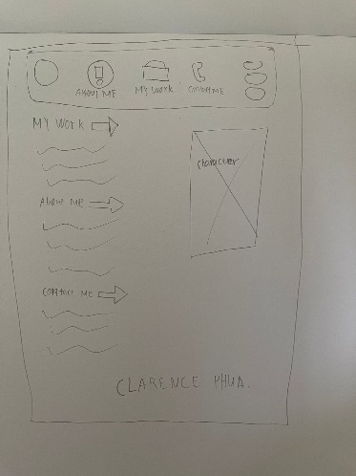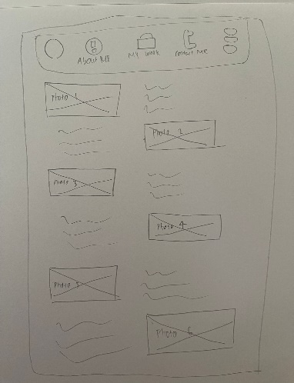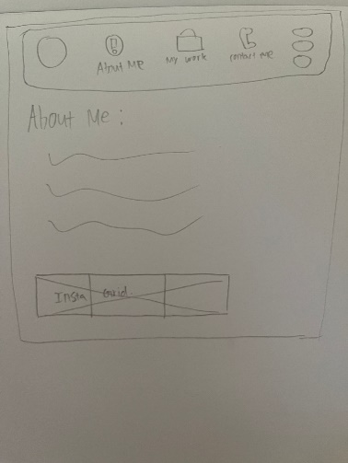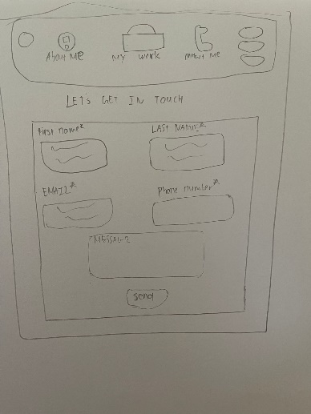
High fidelity wireframe (*Compulsory to fill up for milestone 2 and 3):
Insert your high-fidelity wireframe here. Full set of ALL the pages in JPEG or PDF format.
E.g.
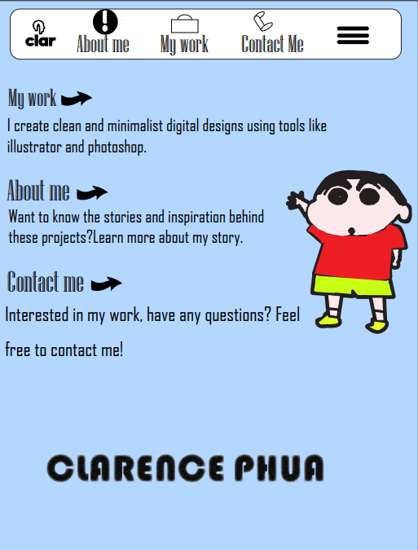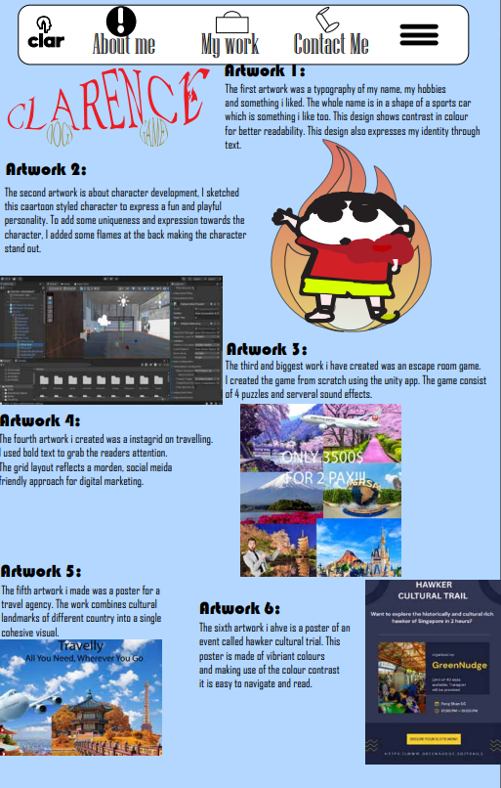

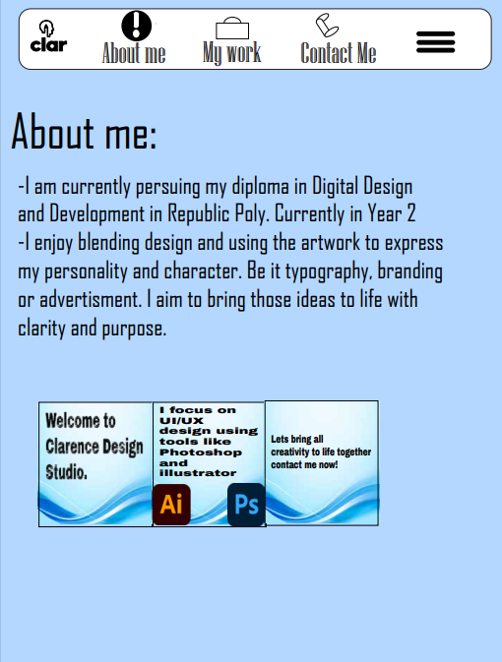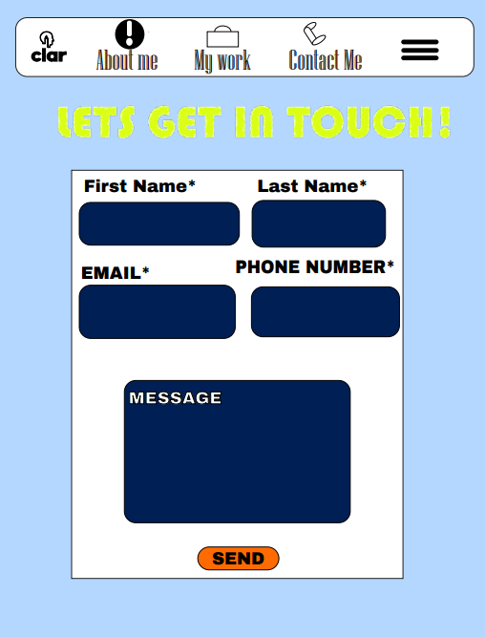

Link to your Prototype – Most likely on Figma (make sure your lecturer is given access to the site) (To fill up for milestone 2 and 3):
https://clarence1129.github.io/clarence.github.io/

Reference sites (*Optional):
Any reference websites you have make references

